Experiment: 3
Name: Riya Dhakaan | Roll no: A044 | Batch B-Tech IT
Year II Sem IV | Date 28.01.2026 | Grade:

Objective:
- Understand and apply discrete probability distributions using R.
- Learn to use R functions to compute probabilities, cumulative probabilities, and simulate random values for discrete distributions.

Code for installing packages:
install.packages(e1071)

Code to load and use package:

library(e1071) library(distr)
Code to remove package after use:
detach("stats", unload = TRUE)

Syntax for working with discrete data is as follows:

ddiscrete(x, probs, values = 1:length(probs)) pdiscrete(q, probs, values = 1:length(probs)) qdiscrete(p, probs, values = 1:length(probs)) rdiscrete(n, probs, values = 1:length(probs), ...)

where
x, q vector or array of quantiles.
p vector or array of probabilities. n number of observations.
Probs probabilities of the distribution. values values of the distribution.

... ignored (only there for backwards compatibility)
These functions provide information about the discrete distribution where the probability of the elements of values is proportional to the values given in probs, which are normalized to sum up to 1. ddiscrete gives the density, pdiscrete gives the distribution function, qdiscrete gives the quantile function and rdiscrete generates random deviates.

X=c(0,1,2,3,4) P=c(0.1,0.15,0.2,0.55) XP=X*P
data.frame(X,P,XP) mean=sum(XP)
TO FIND THE MISSING VALUE IN A PROBABILITY DISTRIBUTION

convert the question of solving the equation to finding the root of a function and use the following steps: ]
For example to find root for 0.6+6x=1, use the following code: f <- function(x) (0.6+6*x-1)
uniroot(f, lower=0, upper=1)$root

TO FIND THE DISTRIBUTION OF A NEW VARIABLE GIVEN AS A FUNCTION OF RANDOM VARIABLE:

x=c(-1,0,1,2)

y=x*x+1 y
prob = rep(1/4,4)

tapply(prob,y,sum)

#Install package install.packages("stats") #To remove package after use
detach("stats", unload = TRUE)
#Load library to load and use package library(e1071)
library(distr)
#Prefix used
- p for "probability", the cumulative distribution function (c. d. f.)
- q for "quantile", the inverse c. d. f.
- d for "density", the density function (p. f. or p. d. f.)
  - r for "random", a random variable having the specified distribution
#Frequency table
random=sample(1:10, size=1000, replace = TRUE) t=table(random)
barplot(t)
#How to enter data
rdiscrete( 30, c(‘0.2’,’0.5’,’0.3’) )
rdiscrete( 100, c(‘0.2’,’0.5’,’0.3’), c(“A”,”B”,”C”))

#Example
y= rdiscrete( 100, c(1/4,2/4,1/4), c(0,1,2)) factor(y)
levels(factor(y)) table((factor(y)))
#To find probability associated to any random variable for example x=1
ddiscrete(1, c(1/4,2/4,1/4), c(0,1,2))

#Example of rolling of die
# generate the vector of probabilities
probability <- rep(1/6, 6)

# plot the probabilities
barplot(probability, xlab = "outcomes", main = "Probability Distribution")
# generate the vector of cumulative probabilities
cum_probability <- cumsum(probability)

# plot the probabilites
barplot(cum_probability, xlab = "outcomes", main = "Cumulative Probability Distribution")
Note: Plots must be customized by using the knowledge of Practical 2.
#Mean and variance X=c(0,1,2,3,4) P=c(0.1,0.15,0.2,0.55) XP=X*P
data.frame(X,P,XP) mean=sum(XP)

#Find unknown for 0.6+6x=1
f <- function(x) (0.6+6*x-1) uniroot(f, lower=0, upper=1)$root

Task 1:
PDF of random variable X is:
X | 1 | 2 | 3 | 4 | 5 | 6 | 7
P(X) | k | 2k | 3k | k² | k²+k | 2k² | 4k²
Find , $E(x)$ and $V(x)$
Write an R program for the above problem. Also, write an R program to plot the probability distribution and cumulative distribution function.
Hint: For creating a vector with cumulative sum of another vector’s elements in R use: cumsum(vectorname

Task 1 – Mean (Expected Value) of X
If I repeat this experiment many times, what value of X do I expect on average?

k+2k+3k+k2+(k2+k)+2k2+4k2=1
8k2+7k−1=0

K =1/8
P(x<5)= 58/64
Mean = 201/64
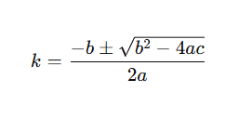
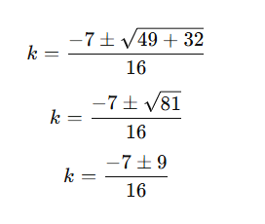
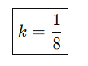

Mean:
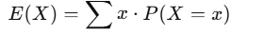
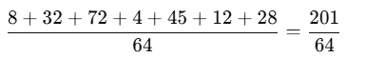
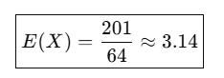

Variance=10607/4096
Variance tells us how spread out the values are from the mean
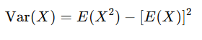
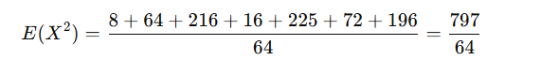
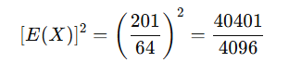
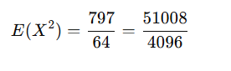
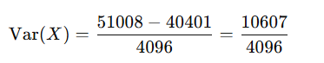
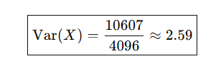
CDF (Cumulative Distribution Function)
What is the probability that X is less than or equal to a value?
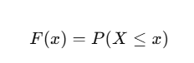
install.packages("e1071")

library ("e1071")
library ("distr")
Code to remove package after use:
detach("stats", unload = TRUE)

x <- 1:7
k <- 1/8
p <- c(k,2*k,3*k,k^2,k^2+k,2*k^2,4*k^2)

EX <- sum(x*p)
VX <- sum(x^2*p)-EX^2
EX
VX
sum(p[x<5])
sum(p[x>=1 & x<=5])
barplot(p, names.arg=x, col="skyblue",main="PDF OF X")

cdf <- cumsum(p)
plot(x,cdf,type="s", col="red",main="CDF of X")
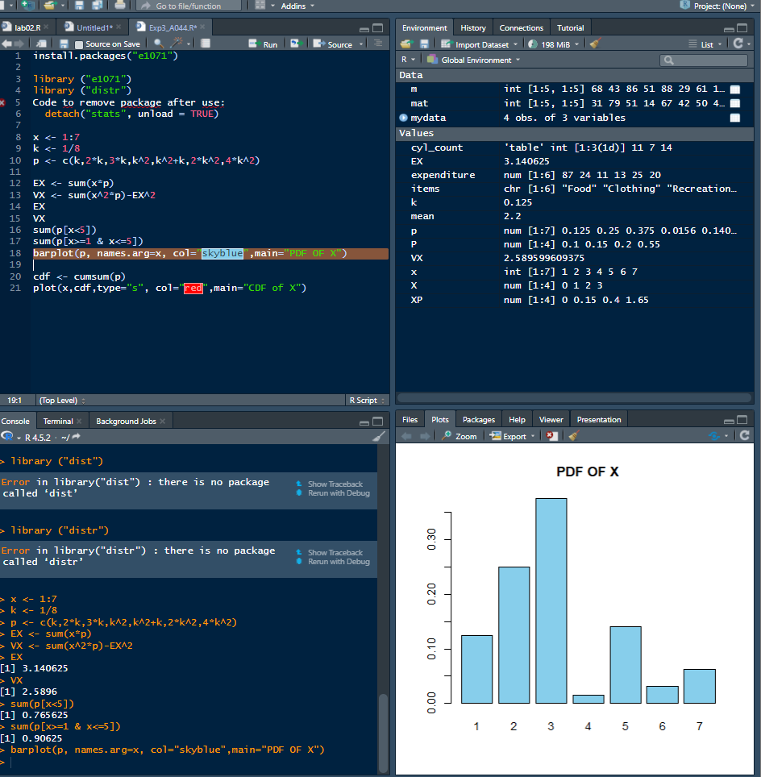
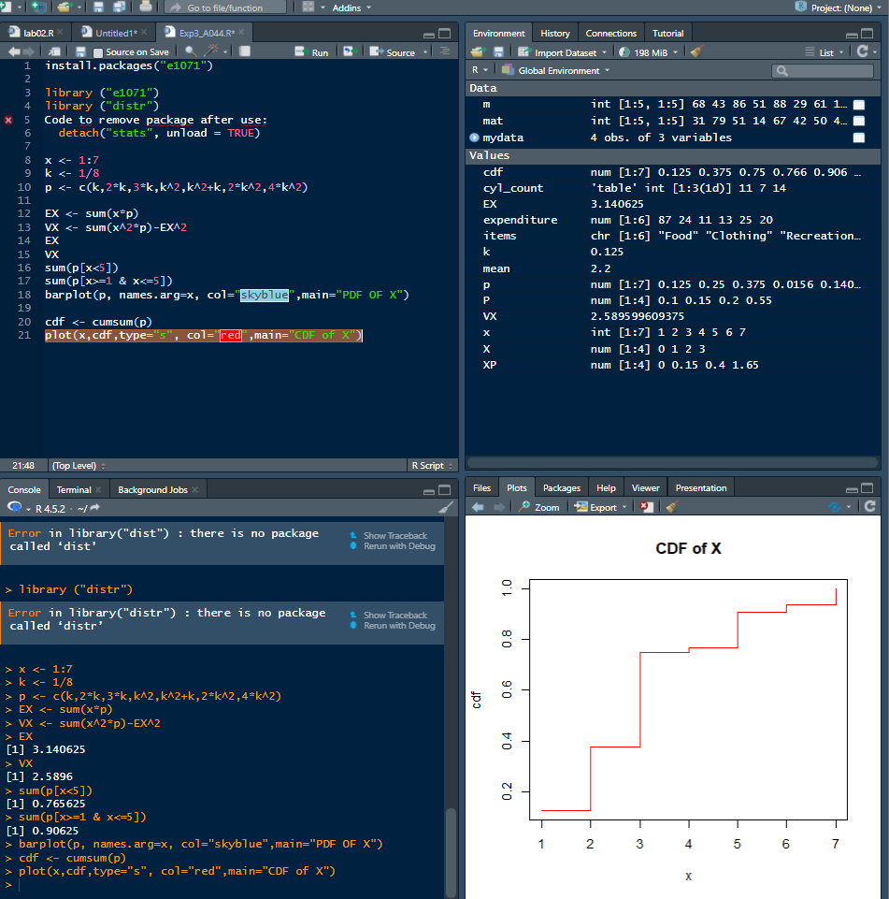Task 2:
A random variable X has the following pdf:
X | -2 | -1 | 0 | 1 | 2 | 3
P(X) | 0.1 | k | 0.2 | 2k | 0.3 | 3k
Find k, P (X <2), cdf, mean and variance of X.
Write an R program for the above problem. Also, write an R program to plot the probability

distribution and cumulative distribution function.
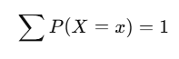
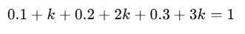
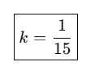

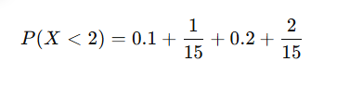
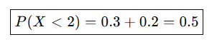

CDF (Cumulative Distribution Function)
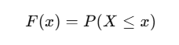
X -2 -1 0 1 2 3
F(X) 0.1 1/6 11/30 1/2 0.8 1

Mean (Expected Value)
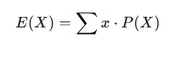
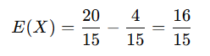
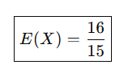

Variance of X
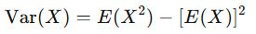
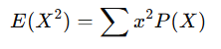
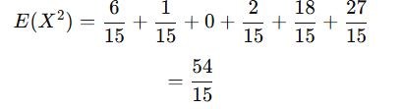
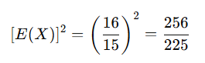
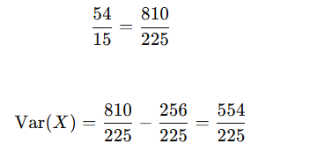
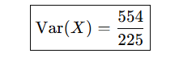
x <- c(-2,-1,0,1,2,3)
k <- 1/15
p <- c(0.1,k,0.2,2*k,0.3,3*k)

sum(p)
sum(p[x < 2])

EX <- sum(x*p)
VX <- sum(x^2*p) - EX^2

EX
VX

barplot(p, names.arg=x, col="lightgreen", main="PDF of X")
plot(x, cumsum(p), type="s", col="blue", main="CDF of X")

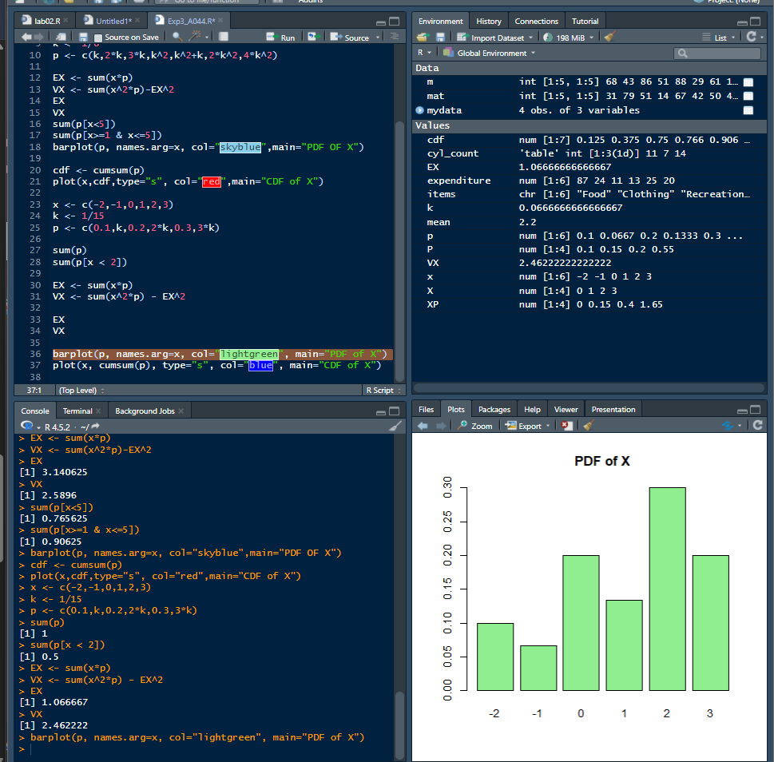
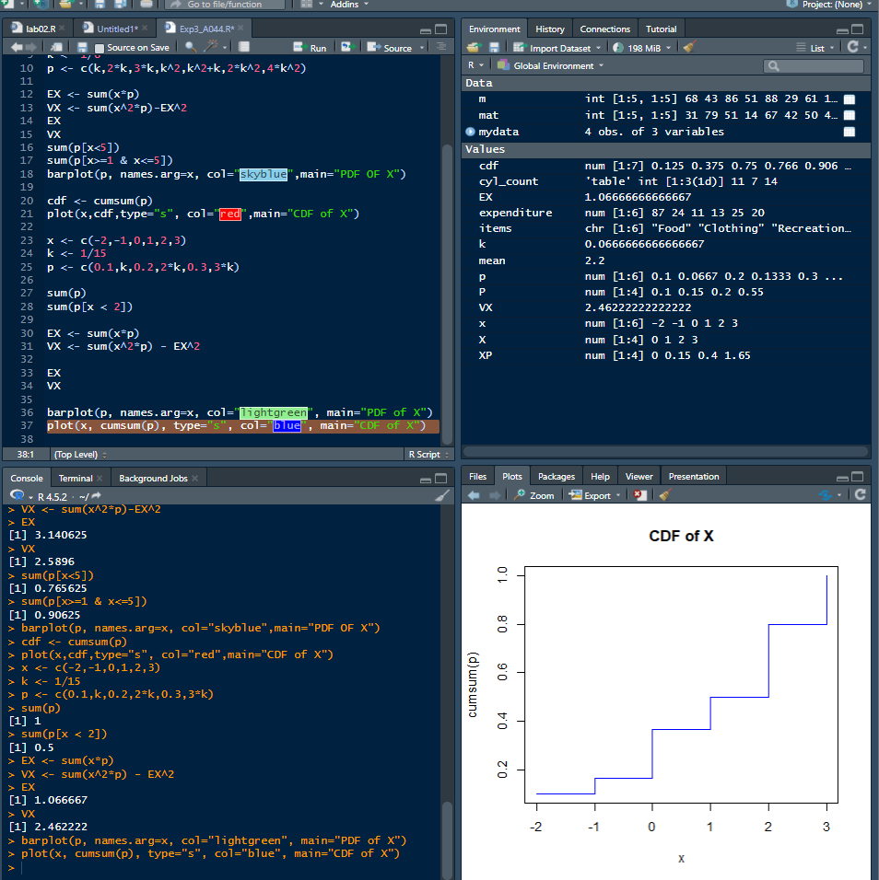

Task 3:
A RV X has the following probability distribution:
X | -2 | -1 | 0 | 1 | 2
P(X=x) | 1/5 | 1/5 | 2/5 | 2/15 | 1/15
Find the probability distribution of Y= X²+1. Also find mean and variance of Y.
Write an R program for the above problem. Also, write an R program to plot the probability distribution and cumulative distribution function.
X | X^2 | Y = X^2 + 1
-2 | 4 | 5
-1 | 1 | 2
0 | 0 | 1
1 | 1 | 2
2 | 4 | 5

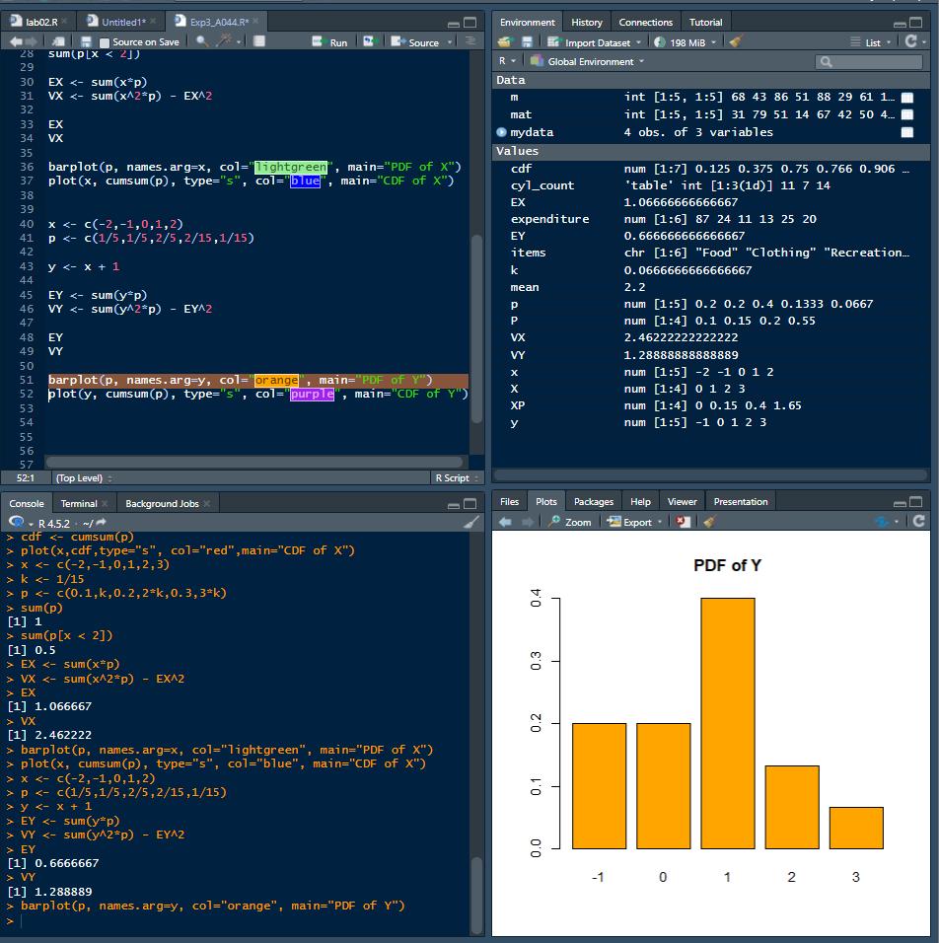

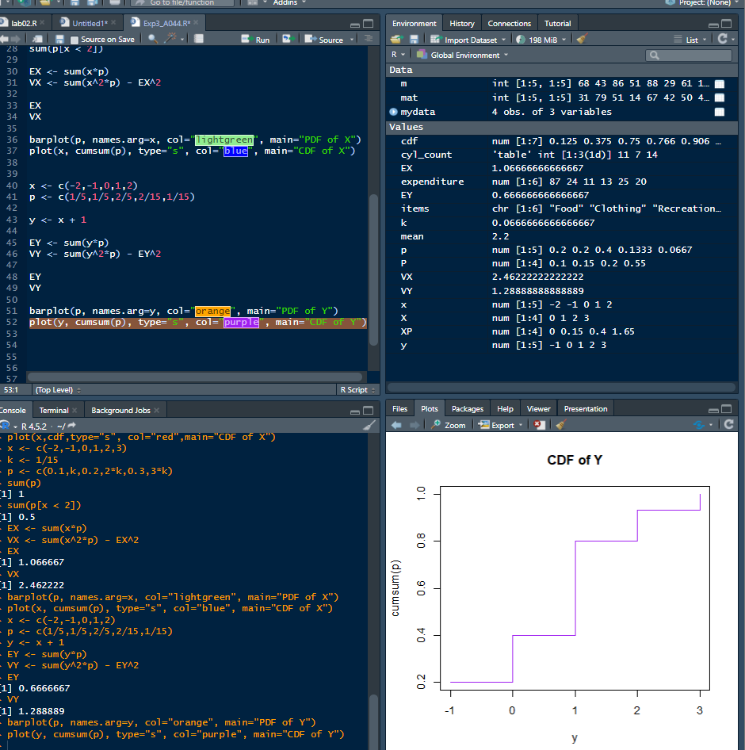

Task 4:
Given the following distribution:
X | -3 | -2 | -1 | 0 | 1 | 2
P(X=x) | 0.05 | 0.1 | 0.2 | 0.3 | 0.2 | 0.15
Find Mean and Variance.
Write an R program for the above problem.
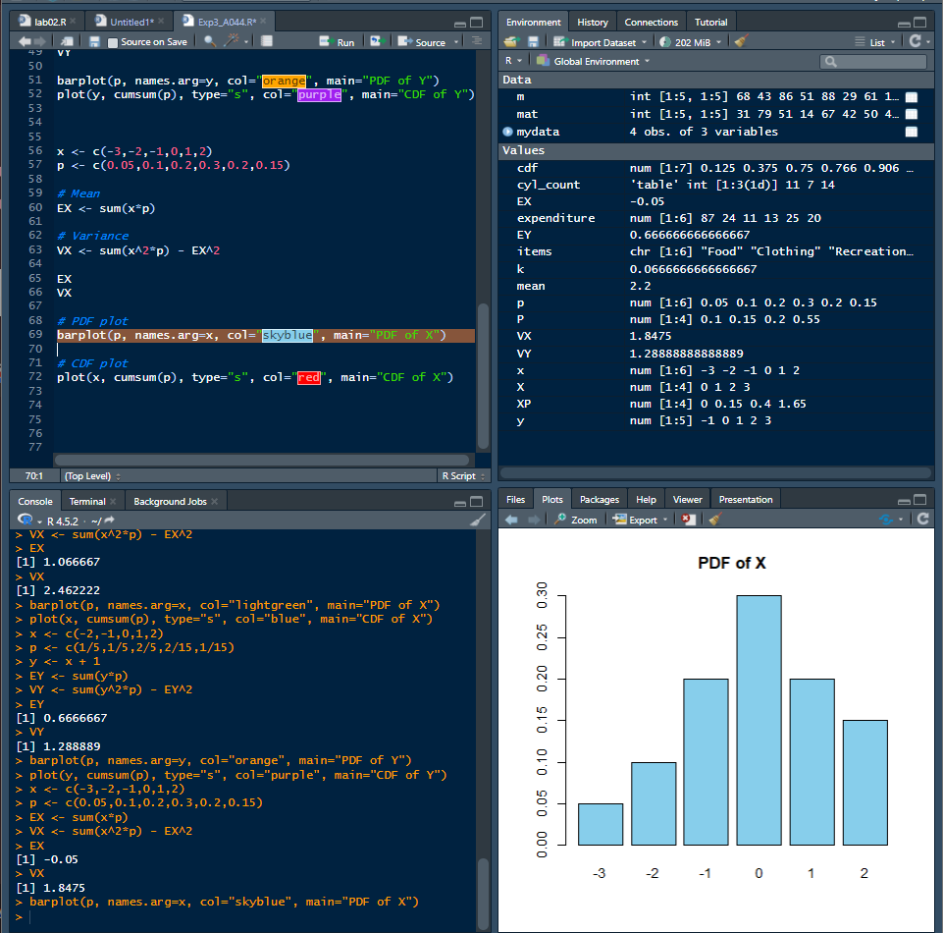
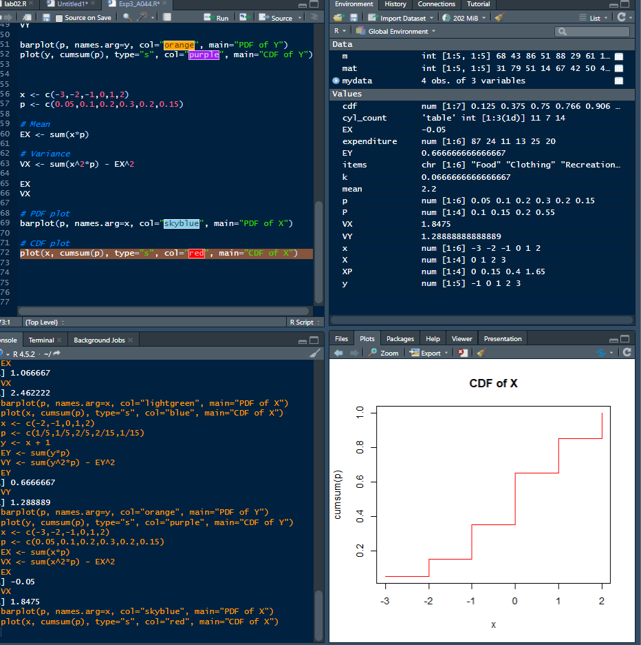
Task 5:
An urn contains 7 white and 3 red balls. Two balls are drawn together, at random from this urn. Compute the expected number of white balls drawn.
Using an R program, find the expectation of the above problem. Also write a program to plot probability distribution and cumulative probability distribution. Hint: For calculating combination in R use: choose(n,r)
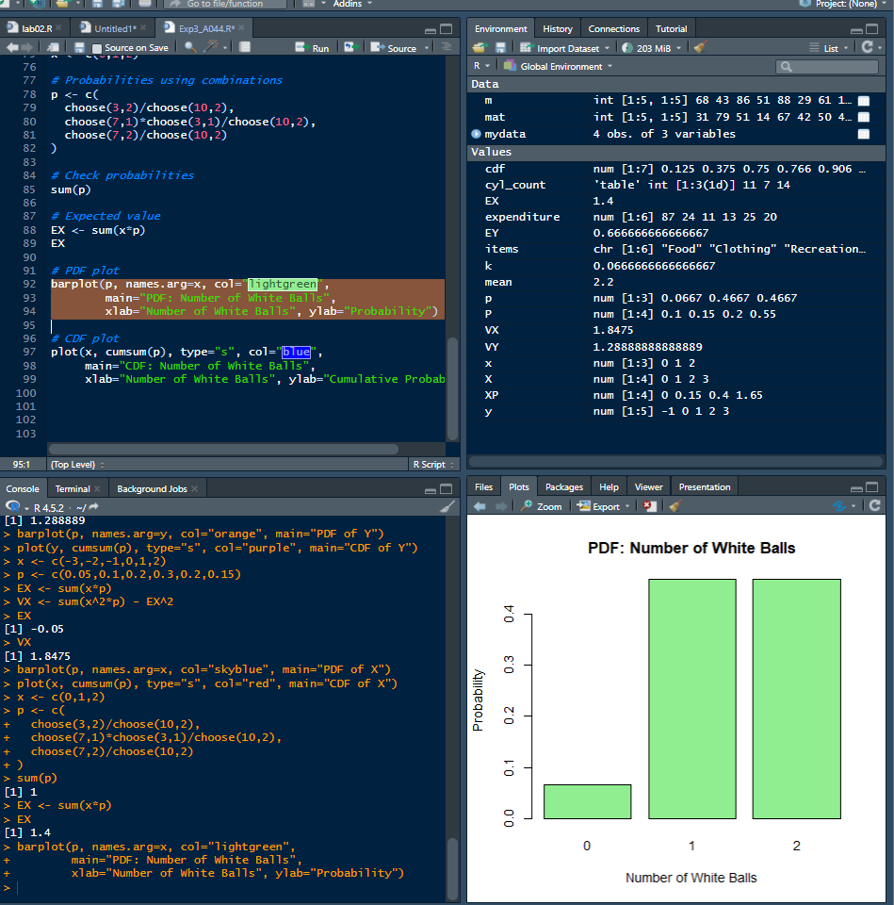
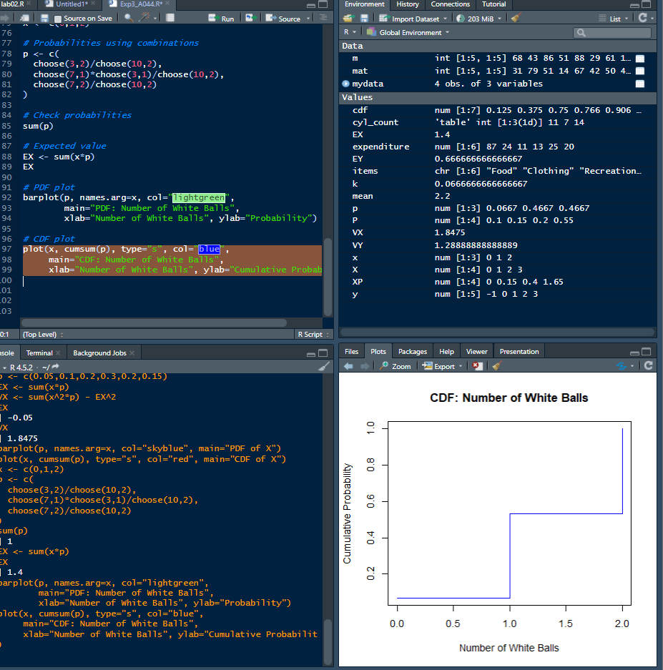
Home Work Questions:

Solve all the above questions manually.

